Daniel Filiuk
PERSONAL DETAILS
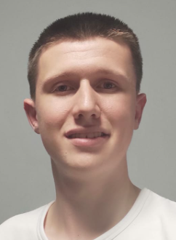
Gmail: danif99@gmail.com
Phone: 0534252513
Birthday: 9.6.1999
Linkedin: https://www.linkedin.com/in/daniel-filiuk-710a17a5/
Github: https://github.com/danif99/ReverseEngineering
SKILLS
Malware analysis & Reverse engineering: Static & dynamic analysis, packers & unpackers, monitor malware, system internals, PE format, ASLR, DEP, Security cookie , ROP, PEB, anti-reverse engineering, detect and defend against malware
RE Tools: IDA-PRO, x64dbg, OllyDbg, WinDbg, Ghidra
Penetration testing : Vulnerability scanning, DOS, brute force, exploiting, privilege escalation ,SIEM
Network security: TCP/IP, ACL, HTTP, DNS, Firewall, ARP, WAN / Lan
- Software and programming language: VirtualBox, Vmware, Assembly X86\X86 64, C, Python, Visual Studio 2019, active directory
- Personal skills: Self-learning, can work well under pressure, flexible, team player, highly motivated, team leader
Military service
- Guide new soldiers
- Responsible for soldiers under my command
- Graduated from Marom Technician, which I graduated with honors
- Works in collaboration with representatives of Elbit
Education
- 2020 – 2021 course: C programming and reverse engineering at Technion + Book: Practical malware analysis
- 2019 – 2020 cyber security and system administrator at Technion, MCSA, CCNA, CCSA, Linux, PT
- 2018: ORT Kiryat Motzkin: 12 years of study, Technological major, matriculation and certificate Technology (electronics)
Languages
Hebrew – native | English – advanced | Russian – elementary

