Updated 09.2022

Michael Rosenthal
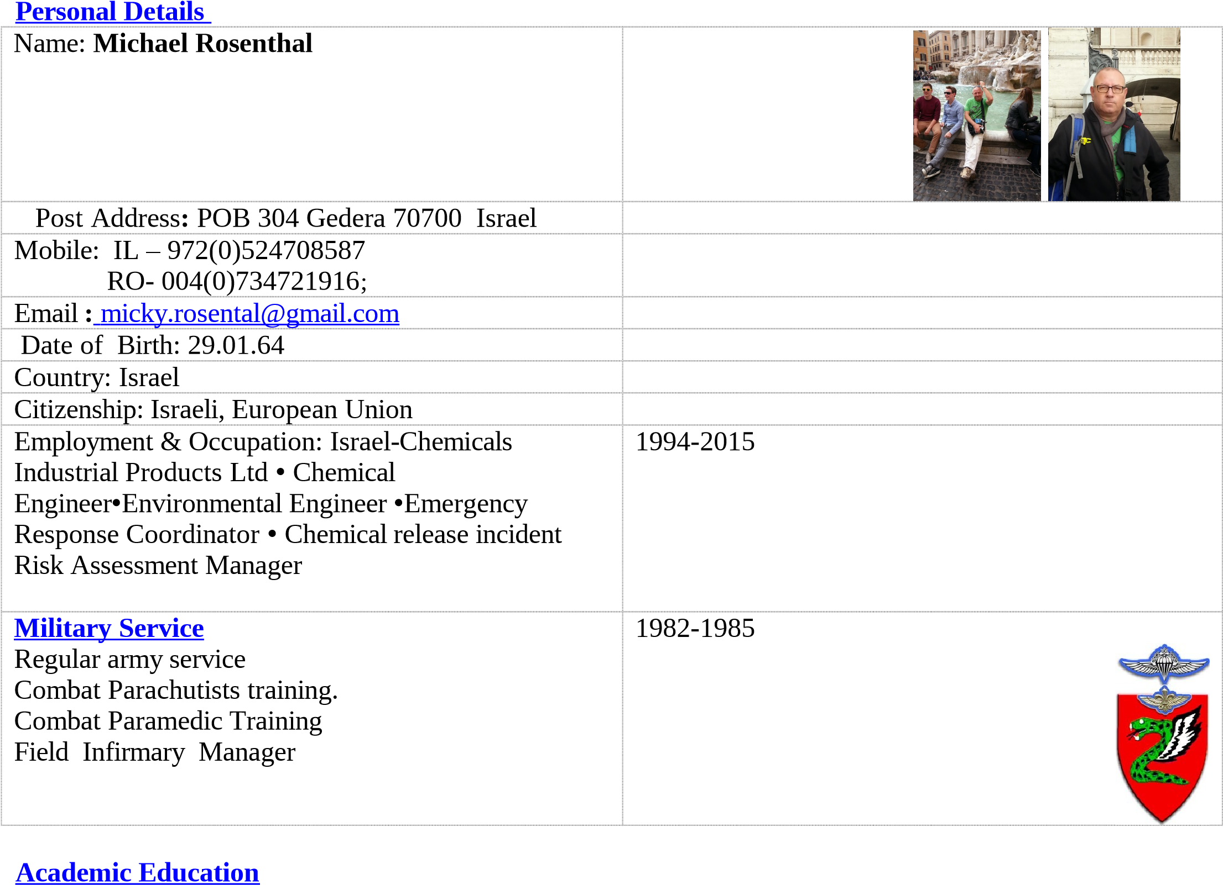
Period University Years Faculty/Department Degree
2015- American 1 MSc International Hospitality &Tourism
2016 Hotel Business Management (in progress)
Academy/
Manchester
Metropolitan University
2000- Ben Gurion 2 Engineering sciences/ Environmental MSc Environmental
2002 University Engineering Engineering

1989- Ben Gurion 4 Engineering sciences/ Chemical BSc Chemical Engineering
1993 University Engineering
(*) Professional Chemical & Environmental engineering diplomas – see separate list

Languages
☑ Hebrew (speak, read, write)
☑ English-Business& Technical (speak ,read, write)
☑ Romanian (speak ,read, write)

Master of Science, MSc by Manchester Metropolitan University, at AHA ,Brasov Romania ( 2016-2017 )

International Hospitality Tourism Business Management
- Marketing classical and Social digital media
- Firm financial analysis
- Hotel Management
- Product development & Marketing in Tourism
- Dissertation-Film Tourism and effect On site Location

Risk Management,Product Safety and Emergency Response ICL-IP ( 2011-2015)
☑ Risk evaluation and assessment for Hazardous Materials and products of ICL group for Emergency Response and preparedness purposes
☑ Product safety management and advocacy
Managing Testing works and Procedures for Hazardous properties ( i.e Explosive and other physical properties). Preparation of Product Safety Handbooks and Safety Brochures for end users, Marketing and sales Departments.
☑ Emergency Response System for Offsite or transportation Incidents. Maintenance Updating and System Testing by performing Drills.
Managing Updating and Distributing of ICL's "Red Book" for Offsite Emergency Response

Sustainability Coordinator R&D Division ICL-IP ( 2009-2011)
☑ Sustainability Coordinator
☑ Product Stewardship program team member
☑ Responsible Care Program team member
☑ ISO 14001 and 18001 Internal Auditor
☑ Social Responsibility ( IS 10000) and Corporate governance team member

Environmental Engineer and Environment & Occupational Hygiene Manager ICL-IP ( 1997-2009)
☑ Environmental & Occupational Hygiene Manager of Ramat Hovav Bromine Compounds production Site. Managing Operations of 5 engineers and technicians in the various environmental fields: Air Pollution monitoring and control, Occupational Hygiene monitoring and control, Wastewater Treatment and control .Hazardous Waste treatment and control .coordination of all work permit activities to meet industry local regulations and beyond.

Corporate EHS Health Safety&Environmental Department ICL-IP ( 1992-1997)
Environmental Engineer at the EHS Departments & Regulatory affairs ICL group
preparing project assessments for environmental Aspects and Due Diligence. Information exchange with legal departments and preparation of environmental statements for Annual Reports and the general public. Environmental Operation permit negotiations with authorities.



