Mor Maslati
Programmer &
Application Developer
e: Mor.Maslati@gmail.com
p: +972-053-5320148
a: 36 Hankin St. Holon, Israel
Personal Proﬁle
Hello. My name is Mor. I live in Israel after moving back from the United States. I have lived in Albuquerque, New-Mexico for 7 years, where I also went to the University of New Mexico. Most of current experience has come from my current position at Mars Interactive. Being able to take an app from an idea all the way to production is the most satisfying feeling to me. I urge you to download my apps, as I am proud to have built them all from scratch, and every challenge was my own to solve. And that is what I’m looking for in the future, new and diverse challenges. So, what are you waiting for, contact me, and let’s make great things happen.

Work Experience
Application Developer at Mars Interactive
2015 - Present
Developing mobile applications for Android devices as well as for Apple devices. As the only application developer at Mars Interactive, I build applications by receiving visual models and UI documents and turning them into code and ﬁnally in to a functional app. The development is done using the Corona SDK program and written in the Lua language. I also work with many other languages, such as: XML, Java, Swift, JavaScript, PHP, REST, Dart .

Ha’Nasi Collage, Ramat-Gan
Programing teacher for JAVA, Android and C#
2015
Teaching application building in JAVA and C# from top to bottom and all that goes along with it, Such as: code writing, logic, debugging, network communication, using external API’s and More…
Team Manager
T-Mobile US / AT&T (New-Mexico, USA)
2007 - 2013
Starting as a representative, I would Walk customers and employees, from all over the US, through technical steps, working with all mobile OS’s (Android, React Native, Corona, Blackberry, Windows). Later as a Team Leader, I would coach T-Mobile representatives using call monitoring and One-On-One coaching, and mainly manage a team of reps on a day to day basis.

Key Skills
*Fluent in Hebrew and English.
*Advanced computer knowledge.

*Experienced in developing mobile applications.
*Experienced in all steps of developing app
Education
Ramat-Gan College (2014)
Android Developer
Course Certiﬁcate in Android Development (native) and Java Programming.

University of New-Mexico/CNM (2010-2013)
Computer Science
3 years studying at CNM (Central New-Mexico College) and UNM (University of New- Mexico), for a degree in Computer Science.
Mor Maslati Resume
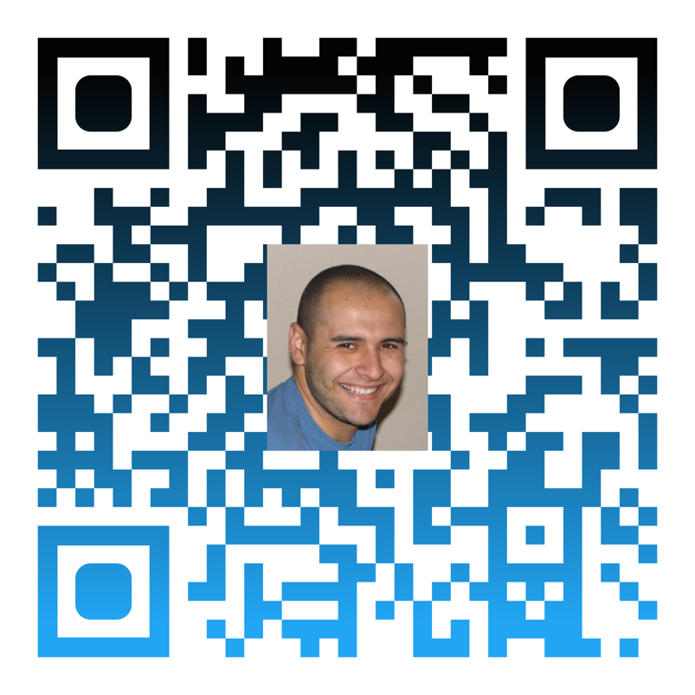

Please click here or scan the QR Code for the latest version of my Resume.
Thank you,
Mor

Keywords: Mobile, Application, Developer, Android, React Native, Flutter, Xamarin, Corona, Lua, Script, JSON, APK.

