Path to a Successful Deployment
Introduction
As mentioned in the course introduction, a Google Workspace deployment for larger organizations is typically managed over three phases. Let’s take a look at these phases and optimum timelines. It is said that there are typically three ‘Go-Lives’ in a Google Workspace deployment:
- Core IT
- Early Adopters, and
- Global Go-Live
While deployments typically run for between 90 and 120 days in large enterprises, it’s useful to think of it as a three month effort. This can be quite helpful in laying out the deployment lifecycle plan for people working in the organization. The diagram below shows the three stages and key objectives of each.
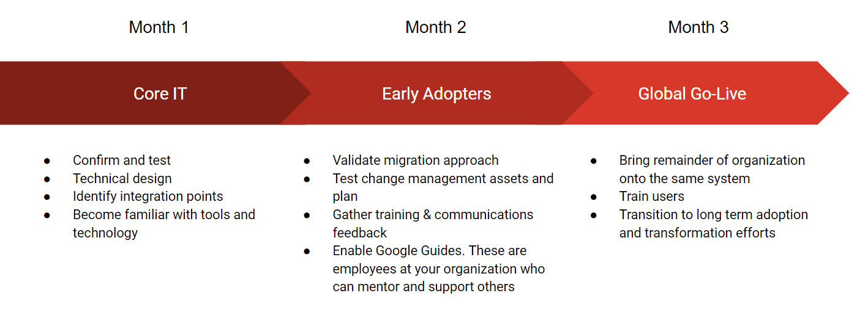
Note that larger organizations will need the deployment to be phased out over a longer timescale, whilst other smaller organizations may move more swiftly.
Follow the guidelines here and the resources linked to from this course and you will achieve a successful deployment for your organization.
Core IT
In the Core IT phase, you’re working with a small group of IT professionals within the organization, upto 25 individuals, and piloting the deployment with them. This phase doesn’t create any change or disruption to the existing IT systems operating there. The successful provisioning for this group is critical in order to be able to proceed to the next phase. It provides an excellent opportunity to identify forthcoming challenges and issues and resolve them at this early stage.
Early Adopters
In the Early Adopters phase, you build on what you have achieved with the Core IT phase. Essentially this is a full deployment, but rolled out to between 5% and 10% of the staff compliment. Now, the Google Workspace deployment is more visible and you can use this phase to step up the technical rollout and especially the Change Management elements.
This phase should not be viewed as a technical rehearsal. It is rather a rehearsal for the organization. It is a Change Management milestone, where user acceptance is built. During this phase you will also enable Google Guides in your organization. These mentors will play a critical role in communicating acceptance and enthusiasm for new ways of working that are facilitated by the technology, Google Workspace.
Global Go-Live
There should be no surprises in the Global Go-Live phase. It’s primarily concerned with bringing the rest of the organization onto the Google Workspace system, thus embedding the Go-Live processes into the business. Pro-active communications and easy-to-find support are essential at this phase. During this phase, you will engage the Google Guides to support the workforce during this larger company Go-live.
As with any IT implementation, fast access to training is essential as there’s a critical window to achieve global user acceptance. Many IT projects fail because people were not adequately supported to use them. There are other reasons of course, but it’s seldom because of a fault in the technology.
As Google itself points out, the technology associated with Google Workspace works, and we know this because it’s working all over the world. Your job is to support your business in deploying Google Workspace and, most importantly, the processes it makes possible.

Mail Delivery during a Google Workspace Deployment
What you need to know
As the technical project lead you need to be aware of how messages reach each user’s inbox at each phase of deployment. This includes:
- Knowing where the MX records are pointing and when to change them
- Explaining how mail is being routed. In particular, you should be able to diagram the mail flow from the current legacy platform to Google Workspace for each transition phase and Go-Live
Mail delivery overview
You manage how your mail is delivered. For example, you may want one of the following scenarios:
- Mail is delivered to your legacy platform, and a subset of your users receives mail in Gmail
- Some users receive mail in Gmail inboxes, and others access mail from your local server
- All users use Gmail exclusively, but messages for unknown users are routed to a special mailbox or to an external server
Deployment scenario
You are meeting with Tunji, to discuss a deployment strategy for routing mail from Galaxy Sola’s existing platform to Google Workspace.
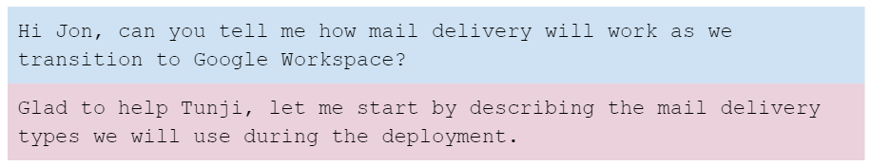
Mail delivery types
Direct delivery
Here, mail messages are delivered directly to the user’s mail platform. This could be the existing legacy platform or Google Workspace.
Dual delivery
Incoming messages are first delivered to the legacy platform. Copies of these messages are then forwarded by the legacy platform to the user’s Gmail inboxes.
Note: It’s also possible to configure dual delivery where Gmail is the primary server, but for our purposes we will assume that messages will be delivered to the legacy platform first.
Split delivery
Incoming messages are delivered to Google Workspace and then routed to either a Gmail inbox or a legacy platform inbox, depending on the user.
Intradomain flow during a Google Workspace deployment
The behavior of on-premises servers (e.g. Microsoft Exchange) is called intradomain flow. This is where messages are exchanged between users in the same domain.
As these messages do not leave the internal network at any time, messages sent from users who are on the legacy platform to users who have moved to Google Workspace may be kept on the legacy platform and not reach the intended recipients' Gmail inboxes.
This can be addressed by creating a forwarding rule for each user who has moved to Google Workspace. Intradomain messages are forwarded to a domain alias (or shadow domain, e.g. apps.galaxysola.com) in Google Workspace. MX records for the shadow domain are configured to point to Google Workspace.
For example, mail for "Tom@galaxysola.com" will be forwarded to "Tom@apps.galaxysola.com"
How does each mail delivery type work?
Direct delivery
Before we start the deployment, Galaxy Sola’s MX records are pointing to our existing mail platform, where all the users receive their mail.
By the Global Go-Live, MX records are changed to Google Workspace, where all users will migrate and receive their mail.
Both of these are examples of direct delivery. These are natural states prior to and after the Google Workspace deployment. Apart from switching the MX records in our DNS registrar's console, no specific configuration is necessary.
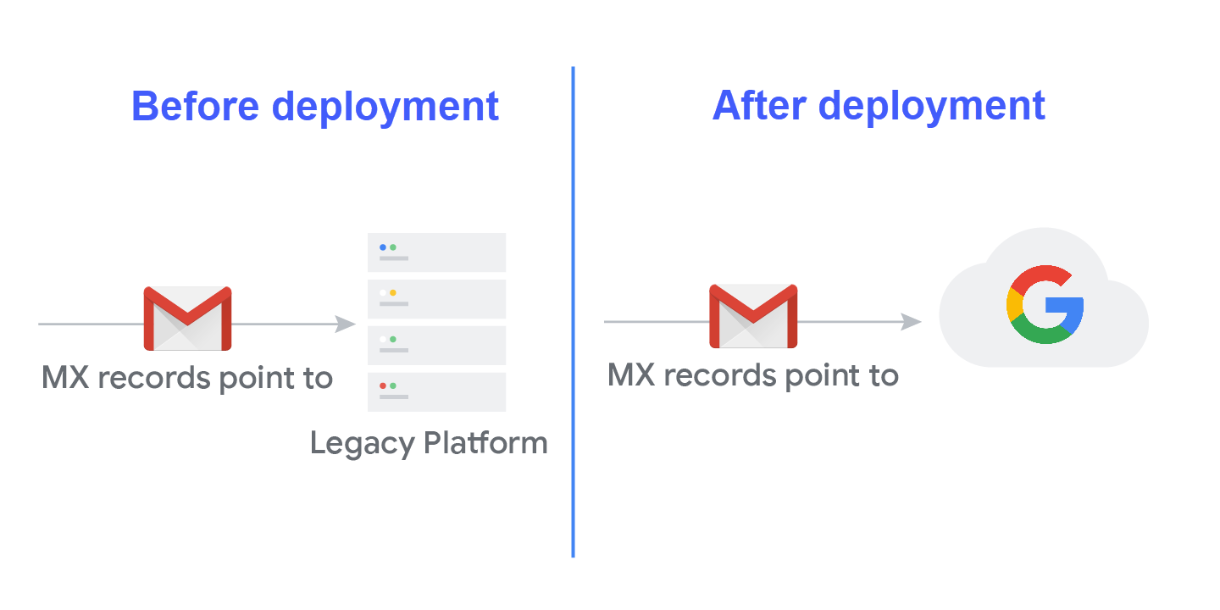
Dual delivery
Galaxy Sola’s MX records are pointing to the legacy mail server, so all messages are delivered here first.
For each user who has migrated to Google Workspace, we configure a forwarding rule from the legacy platform to their Google Workspace account using a domain alias whose MX records are pointing to Google Workspace.
For example, Arthur's mail is forwarded to Google Workspace, while Carol's is not.
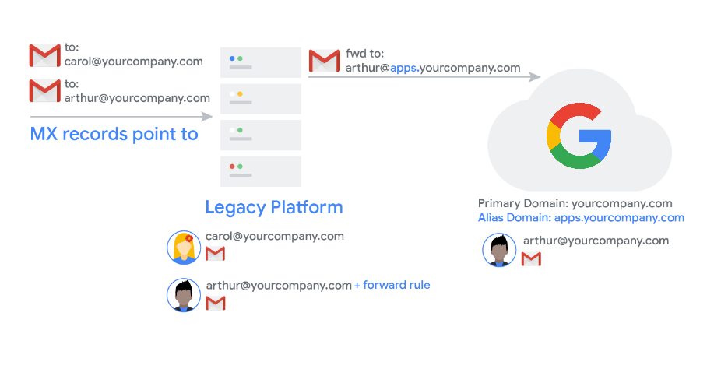
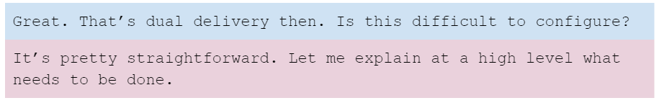
Step 1: Set up a domain alias
Dual delivery is used during the Core IT phase to forward messages from our existing mail system to the Google Workspace users at apps.galaxysola.com. This is also needed during the Early Adopters phase as we move those users over to Google Workspace.
We start by adding the domain alias apps.galaxysola.com to the Google Workspace admin console. We do that from the Domains page. Once added we verify it using the TXT record that is created for us by Google Workspace. As we discussed earlier we will need to login to our DNS registrar’s console and add the new record. We must also ensure that the MX records for the alias are pointing to the Google servers.
Step 2: Configure an inbound gateway
As we deploy more users, we want to ensure that messages that are forwarded from our current mail server are not classified by Google as spam. To do this, we configure the Inbound Gateway setting in Google Workspace with the IP addresses of our existing mail server.
Step 3: Create forwarding rules
For each user who is switching to Google Workspace in the Core IT and Early Adopters phases we must also add a forwarding rule that sends any messages received in their current mailbox to their Google Workspace mailbox.
During Core IT when our MX records are pointing to our existing mail server, all Core IT mail is first routed to here and then forwarded out to Google Workspace. At the Early Adopters stage we switch our MX records to Google but we must retain the forwarding rules so our Google Workspace users can continue to receive intradomain mail.
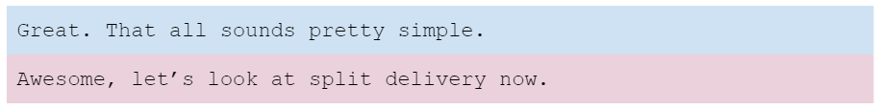
Split delivery
We configure split delivery in Google Workspace during the Early Adopters phase. This is when the MX records have been changed to point to Google Workspace, so all mail messages are now being routed to Google Workspace.
Users who have switched to Google Workspace receive their messages directly in their Gmail inboxes.
For users who have not yet switched, Google Workspace routes their messages back to our existing mail server.
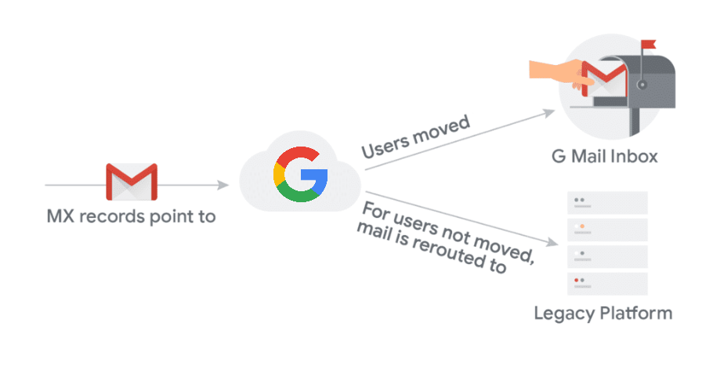
Split delivery is configured to route messages back to the legacy platform based on the Organizational Unit and default routing policy for users still on the legacy platform. Configuring split delivery in the Google Workspace admin console is done as follows:
Step 1: Create an Organizational Unit (OU) for all legacy mail users
Add a new OU called “Legacy Users” OU to the Google Workspace admin console and ensure the remaining legacy platform users (our Global-Go Live users) are in that OU.
As we will provision user’s with GCDS we can place the Global Go-Live users into this OU at the point of provisioning by mapping a custom AD attribute to the OU in Google Workspace.
Step 2: Create a routing policy
We now add an OU routing policy for the "Legacy users" OU. This is done by:
- Adding a “Routing setting” or “Route” for the legacy mail server to the Google Workspace console. This route contains the IP address or hostname of our existing mail server.
- Once we have defined the route, we apply the route to the Legacy Users OU.
Once the route is applied to the Legacy Users OU, all mail messages sent to users not yet migrated to Google Workspace are sent to the legacy mail platform instead for delivery.
Step 3: Set up a default routing policy
Finally we configure the default routing policy to the legacy platform. This reroutes the mail back to the legacy mail platform as a catch-all for any address (user, group or alias) that is not on Google Workspace yet.
Strictly speaking, a default route is not necessary to implement a split delivery architecture, however it is recommended as it ensures no messages are lost. For example, in the event that we fail to provision everyone in Google Workspace correctly.
Help Center resources
- Google IP address ranges for outbound SMTP
- Set up email routing
- Set up an inbound mail gateway
- Configure Default routing

Mail Routing Strategy
Developing a mail routing strategy
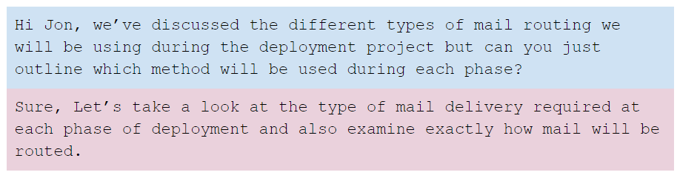
Before starting deployment
- This is where we are today. Direct delivery is implemented for all of our users on the legacy platform, where the MX records are pointing
Core IT
- MX records remain pointing at the legacy mail server. Users not part of the Core IT group continue to receive mail delivered direct to their inbox as they do today
- Dual delivery is used to forward mail to Core IT users with a domain alias. MX records for the domain alias will point to Google Workspace
- We will also configure the inbound mail gateway for Google Workspace so that Google doesn’t classify messages forwarded from our existing platform as spam
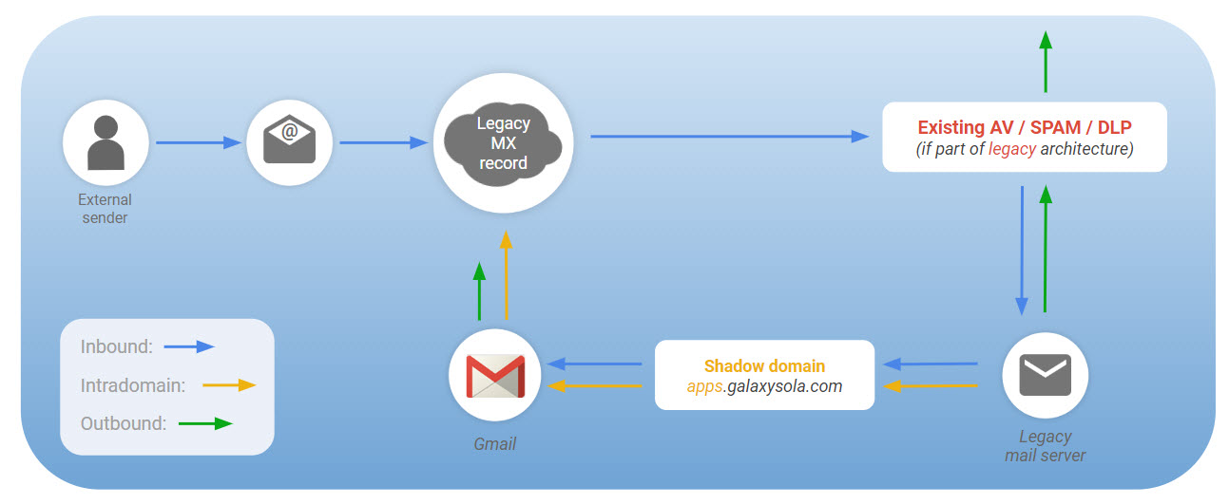
AV = Antivirus, DLP = Data Loss Prevention
Early Adopters
- MX records for the primary domain are changed to point to Google Workspace
- Split delivery is implemented at this stage. Mail received by Google destined for users who remain in the legacy platform is routed back to the legacy mail server for delivery. Dual delivery remains in place for users who have moved to Google Workspace to ensure intradomain mail is received
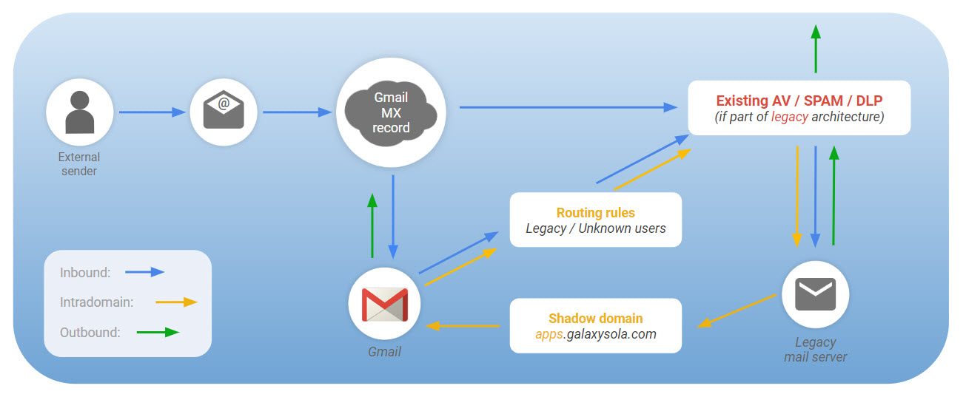
AV = Antivirus, DLP = Data Loss Prevention
Global Go Live
- MX records are already pointing to Google Workspace
- All users are now on Google Workspace and receive mail directly
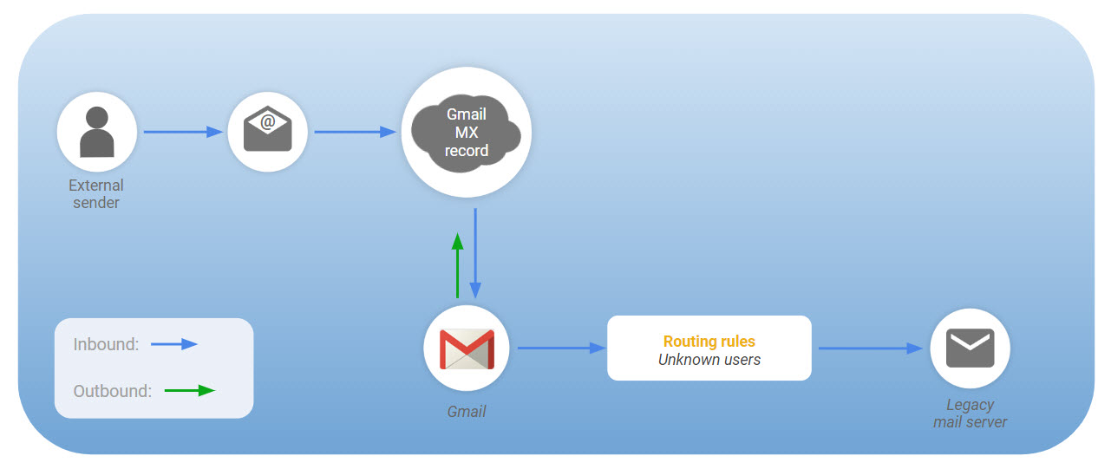

Data Migration during a Google Workspace Deployment
What you need to know
The technical project lead needs to be aware of many factors as they develop a migration plan. Questions that need to be answered include:
Whose data are we migrating?
- Data usage and migration requirements can vary depending upon the user
What kind of data are we migrating?
- There may be different requirements for mail, calendar, contacts, etc
How are we going to migrate the data?
- Choosing server-side versus client-side and developing a data migration strategy
- Investigate data migration tools like Google Workspace Migration for Microsoft Exchange, Outlook or Notes, the admin console's Data Migration Service, and third-party tools
When are we going to migrate the data?
- Do we migrate just enough for the Go-Live and do the bulk historical mail after the Go-Live.
- How do we handle the fact that calendar events and contacts can be changed in the legacy system
Deployment scenario
You are meeting with Tunji to help answer questions around data migration. Tunji, wants to know more about migrating data to Google Workspace.
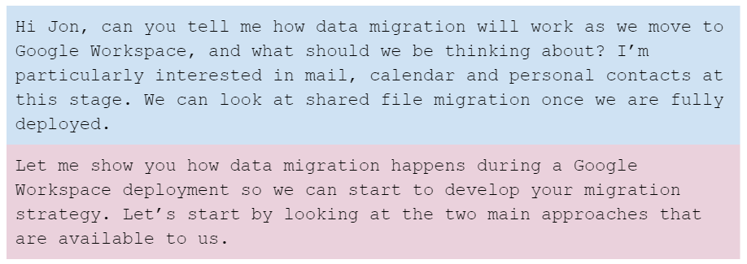
Server-side versus client-side
With data migration, choosing between a server-side or client-side approach determines which tools we will use, who runs the migration, and how data is actually migrated to Google Workspace. This will depend on factors such as who owns the migration and where the data to be migrated resides in the existing environment.
Server-side migration
- Migrations are managed by IT administrators. There is little or no end-user effort required and migrations happen behind the scenes
- Server-side migrations are preferred if data being migrated is already server-based, or migrations need to be centrally controlled
- Considerations: This approach typically requires the deployment of additional servers to host and run the migration software; however this approach offers more control and reporting over client-side migrations
Client-side migration
- Users install and run the migration software locally
- Client-side migrations are useful if the data is stored locally (ex: local PST files), and where centrally managing migrations isn't important
- Considerations: We may need to stagger migrations so that our networks are protected from performance issues. Also, we will need to train and support our users in the migration process? This approach is more difficult to manage and monitor than a server-side solution
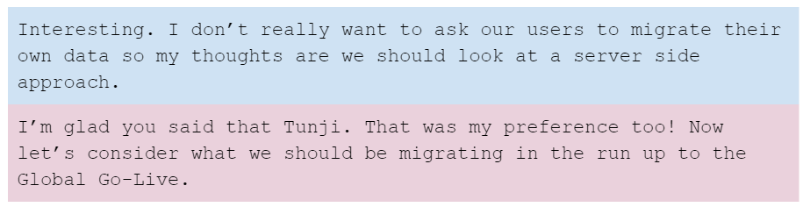
How much data do you migrate for the Go-Live phase?
There are three options available to us.
Migrate nothing
We might choose to migrate nothing. In this case the user’s inboxes will only contain new messages after they switch to Google Workspace. Old messages would need to be accessed from the legacy mail platform but we could make that read only as we wouldn’t want users to continue to send mail from our current system.
In many ways, this is the best option as time is not spent on setting up data migration. Instead we can focus on other deployment efforts. However, this does put an additional burden on our users as they will need to switch between two systems for some time going forward.
Minimal migration
Here we decide how much data we migrate for different sets of users. For example, we might choose to migrate 90 days of historical email along with full calendar and contacts migration for most users. Then for our executive and other selected users we might perform a full mail, calendar and contacts migration.
We should look at our different user profiles and agree what should be migrated for each of them.
The benefit of this approach is time. Full migrations take time and resources. We migrate only what users need for the Go-Live and if required we can come back and migrate older mail later.
Complete migration
We could choose to migrate everything for everyone. This is not ideal however because too much time spent on data migration can extend the project.
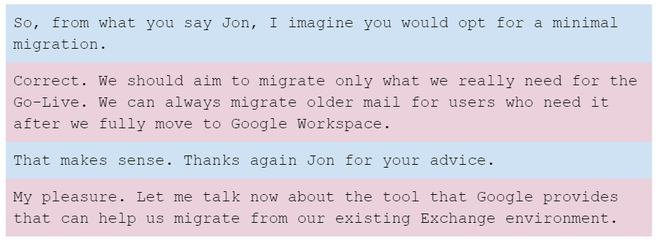
Migration tools
Google Workspace Migration for Microsoft Exchange (GWMME)
GWMME is a server-side tool that migrates email, calendar, and contact data from Exchange.
The GWMME tool runs on its own machine and connects to the Exchange server. Then it migrates data over to our Google Workspace domain for the list of users we specify.
We can increase the amount of data migrated by running multiple machines simultaneously.
GWMME can also migrate PST files for us as needed. Instead of pointing the tool to Exchange, we point to a folder structure instead. This could be useful if we choose to migrate PST archives after the Go-Live.
The migration sequence of events are shown here:
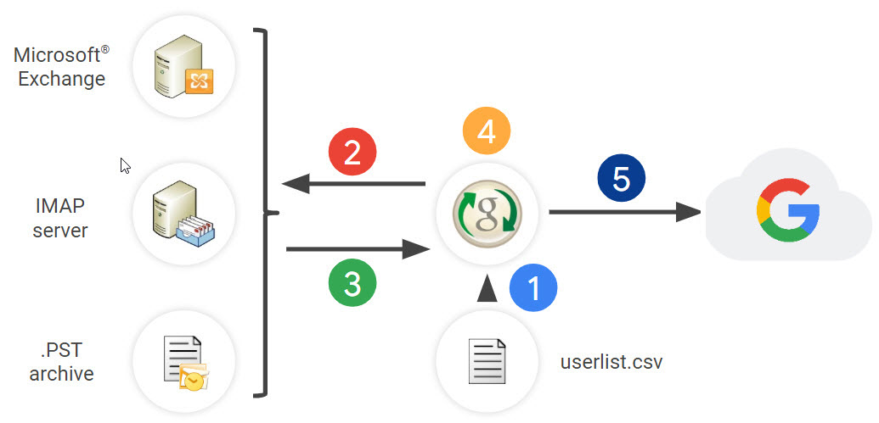
- We create a .CSV file containing the email addresses of users to be migrated.
- GWMME connects to the Exchange server (or other data source) to retrieve user data.
- Data is sent to GWMME for processing.
- GWMME converts the data to the format specified by the Google API’s.
- Data is inserted over Https into the user’s Google Workspace account.
The diagram below shows how GWMME is typically configured.
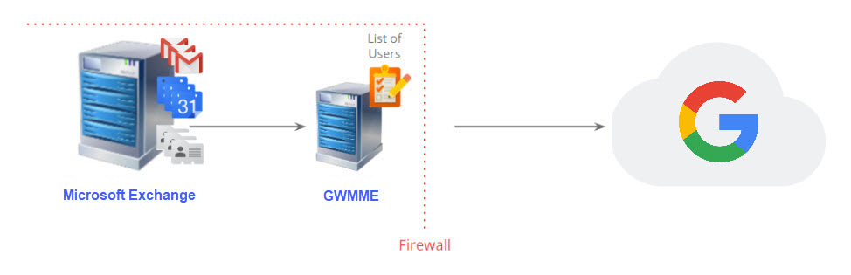
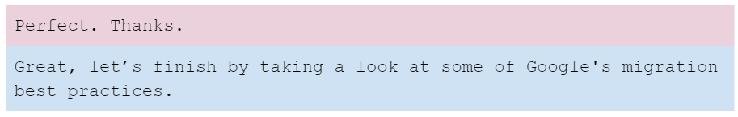
Migration best practices
- Colocate migration servers with mail servers for best performance
- Avoid migrating via a proxy server or firewall. These will impact performance and in some cases migrations can fail
- Always run a set of test migrations to help estimate actual migration times
- Scale the number of migration servers to meet the migration estimates
- Monitor migrations so any failures can be addressed early
- Migrate archives after the Go-Live not as part of the deployment project
- Migrate calendars and contacts just before the user's switch to Google Workspace
- Locate your migration servers close to the internet connection
Help Center resources
The links below include links to Google’s other migration tools.
- Google Workspace Migration for Microsoft Exchange
- Google Workspace Migration for Microsoft Outlook
- Google Workspace Migration for HCL Notes
- About the data migration service
- About Google Workspace Migrate
The Google Workspace Marketplace offers third-party tools to run migration, or you build your own migration tools using Google's Gmail API.

Data Migration Strategy
Developing a data migration strategy
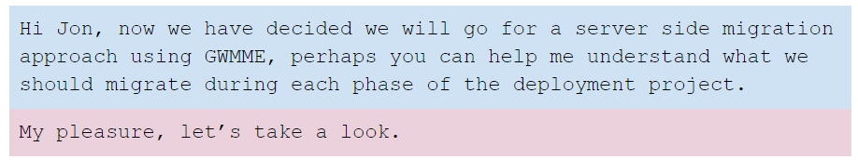
Before starting deployment
- Here we will need to make the decisions around what to migrate for our users. We might choose 90 days of email plus all calendar and contacts for the majority of users and all mail, calendar and contacts for a smaller set of users
- Now is also a good time to start thinking about setting up a migration server so we can run some tests. This not only allows us to estimate migration times but it will also allow us to prove connectivity between our network and Google Workspace
Core IT
- Partial migration of mail
- Full migration of calendar and contacts for these users
Early Adopters
- Partial mail data migration
- Full migration of calendar and contacts data
- Start to run some more extensive test migrations in readiness for the Global Go-Live
Global Go-Live
- Partial/Full mail data migration depending upon user type
- Full migration of calendar and contacts data
Post Go-Live
- Continue migration of historical mail data
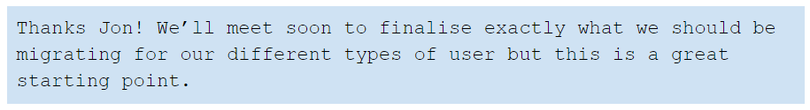

Introduction to Coexistence
In this lesson we'll be looking at how to manage Google Workspace alongside your legacy platform during the Google Workspace deployment, and the best practices for handling coexistence.
In this section, you'll learn:
- How legacy platforms coexist with Google Workspace
- What coexistence strategies should be used during each phase of deployment

Types of Coexistence
What you need to know
Coexistence refers to the situation where we have both Google Workspace and the legacy platform(s) in place at the same time. As Galaxy Sola is a large deployment and will be moving users to Google Workspace over a number of months in a phased deployment, users will need to coexist on both platforms. As the technical project lead, you need to understand:
- The different types of coexistence
- The options available to mitigate coexistence issues
- Best practices from Google on managing coexistence
Deployment scenario
You are meeting with Tunji, to help him understand the challenges users will face during the deployment when some users have moved to Google Workspace, whilst others remain on the legacy platform.
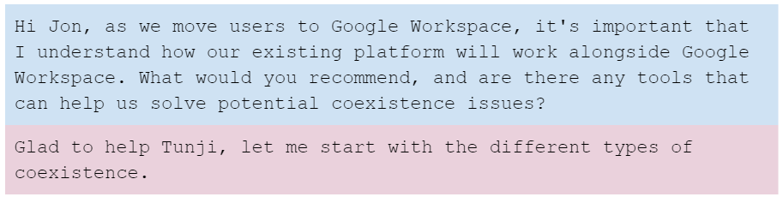
Types of coexistence
Short term coexistence
In a small deployment, coexistence timeframes can be very short, but larger deployments like ours can take months to complete, and coexistence across multiple services is sadly unavoidable.
Even so, with our 90 day plan, this is still considered a short term coexistence period.
Long term coexistence
Google does provide tools to address some coexistence issues such as sharing free/busy information across multiple platforms. However, they do not actually recommend the use of these tools as they can extend the project timelines and any long term coexistence does not offer the best user experience.
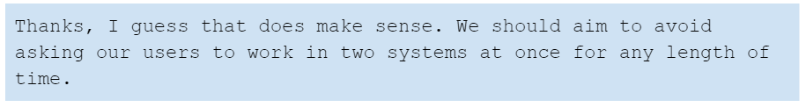

Managing Calendar Coexistence
Managing calendars during deployment
Tunji wants to know more about how to manage calendars during deployment.
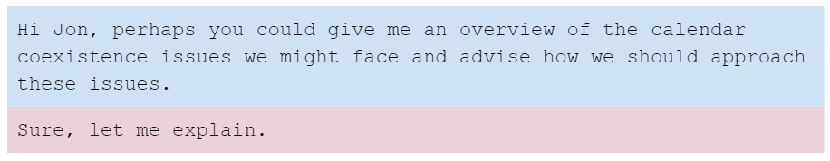
Having some users schedule meetings in Google Calendar while others schedule meetings in the legacy platform's calendar presents several coexistence challenges. Here are some examples:
- How does a user on one platform check the availability (free/busy status) of a user on the other platform?
- How should resources be maintained across both platforms?
- How can a user on one platform view the attendee status of a user on the other platform?
Google provides services and tools that allow users deploying from common legacy platforms to share free/busy information with each other. However, these may not address all coexistence challenges for all organizations.
The recommended approach for the free/busy challenge
Using Google's services and tools should be avoided.
- Smaller organizations may be content to live with the lack of free/busy sharing for a short period while they deploy their users to Google Workspace
- Users who have switched to Google Workspace already can continue to switch back to the legacy calendar system to check the availability of other users
- Larger organizations may choose to migrate users based on free/busy needs. For example, they may choose to migrate users by location where everyone in one building shares the same resources
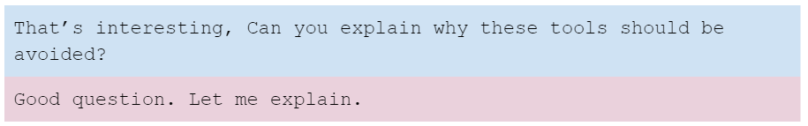
The tools are highly complex and time-consuming to configure. We would need to account for planning, installation and testing in our deployment plan even though these tools will only be used for a very short period of time and be discarded at the Global Go-Live.
We should weigh up the costs in time and effort over the actual benefits offered to our users.
They only solve some of the problems with interoperability between legacy calendar platforms and Google Workspace. There’s no seamless solution available.
And there is a tendency to become reliant on them. This can extend the project which we should avoid as these tools were never designed for long term coexistence.
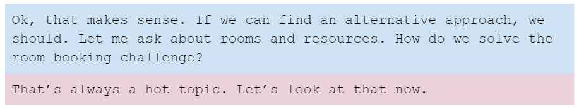
Solving calendar resource issues during coexistence
Google Workspace uses calendar resources to manage rooms and other reservable equipment. During coexistence, double booking can occur if resources are bookable in both platforms. We want to avoid the potential for double booking. There are a couple of approaches we might consider:
Option #1: Book all calendar resources in the legacy system
We could instruct all users to continue reserving resources in the legacy system. This makes it easier to manage because all resources remain in one place. This should be quite acceptable for our Core IT users.
Option #2: Move over selected calendar resources for our Early Adopters
Our Early Adopters can also continue to book resources in the legacy platform. However, if we can identify resources that are only bookable by our Early Adopters, we can add them to Google Workspace and prevent bookings from being made in the legacy calendar system.
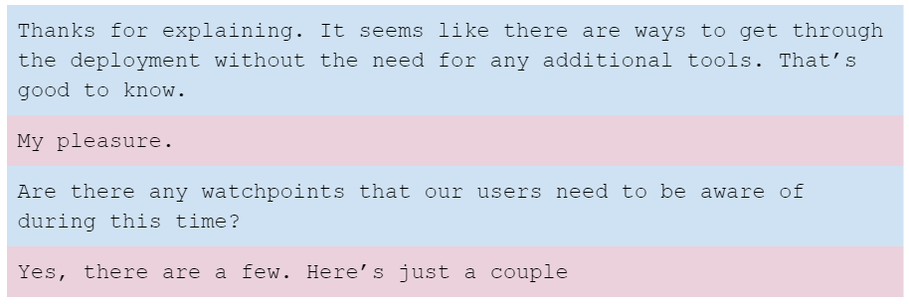
Watchpoints
Primary calendars
Users provisioned in Google Workspace that have not yet started to use Google Workspace (e.g: Global Go-Live users that are provisioned in Google Workspace at the Early Adopters phase) should be placed in an OU with the Calendar service disabled. If these users are in an OU with Calendar enabled, the following issues may occur:
- User's on the legacy platform may receive reminders from Google Calendar
- If a legacy user disables notifications in Google Calendar, they will not receive invitations to new meetings sent by other Google users
- The time zone of the calendar in the invite may also be incorrect
Only once a user is migrated to Google Workspace should they be switched to an OU with Calendar enabled.
Inviting groups to calendar events during deployment
Legacy users who invite distribution lists should expand their lists in order to invite all appropriate users in Google Workspace. If they do not, the calendar invites will not be forwarded to the users who have migrated to Google Workspace, such as the Early Adopters.
Updates to an event
When a Google Calendar event owner changes an event, they have the option to send the update via email to all attendees. If all attendees are on Google Workspace, this is optional as Google Calendar will ensure the event is updated for everyone. However, if any attendee remains on the legacy system the Google organizer must ensure the updates are sent otherwise the attendee will not see the change made on their calendar.
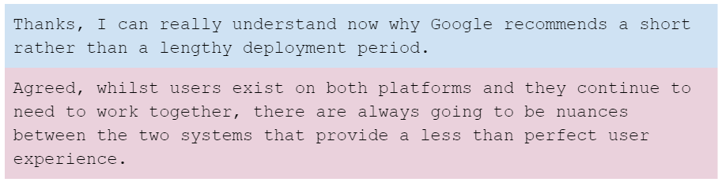
Help Center resources
- About Calendar Interop
- Share availability with HCL Notes
- About Google Calendar Resource Sync

Groups and Shared Contacts
Managing groups and shared contacts during deployment
Tunji now wants to understand more about how to manage groups and shared contacts during deployment.
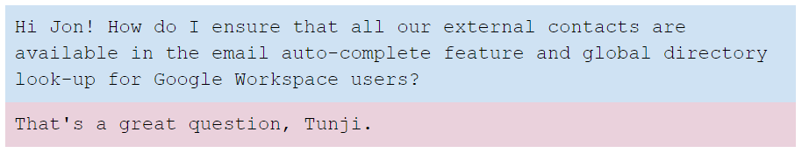
Directory lookup for groups and shared contacts
During deployment, not all addresses will appear in Google Workspace’s auto-complete feature and global directory look-up. These are typically groups and users who are external to the organization that is deploying Google Workspace.
To resolve this, external contacts can be added to the Global Address List (GAL) using Google Workspace Shared Contacts tools. We have a number of options available:
We could use GCDS for this purpose. Alternatively, there are a number of third party applications in the Google Workspace Marketplace, or we could even develop our own tool using Google’s Shared Contacts API (this is the same API that is used by GCDS and other tools).
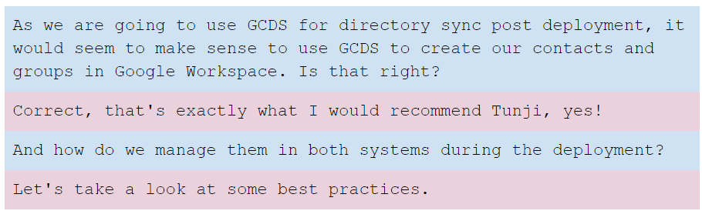
Best practices for managing groups and shared contacts during deployment
With coexistence, we will need to manage our groups and external contacts living on both the legacy platform and Google Workspace.
Groups
During the Core IT phase, we just need to ensure the groups on our existing platform can receive email from the internet.
We could add our groups as shared contacts in Google Workspace so the addresses appear in the GAL but we would need to come back and delete these later - so my recommendation would be to avoid that approach.
Once we enter the Early Adopters phase we should add the groups to Google Workspace using GCDS.
Shared contacts
Shared contacts can be added to Google Workspace at any phase of the deployment but it makes sense to use GCDS so we should do that when deploying the tool at the Early Adopters phase.

Coexistence Strategy
Developing a coexistence strategy
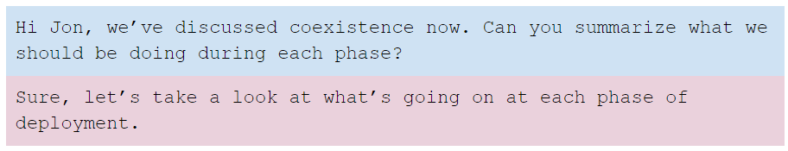
Before starting deployment
- Identify which users must move together to Google Workspace
- Decide whether free/busy status should be shared between Google Calendar and the legacy system
- Plan for deployment accordingly
Core IT
- Users: Provision Core IT users only
- Shared Contacts: Do not provision external contacts at this time
- Groups: Ensure legacy groups can receive email from Google Workspace
- Calendar resources: Instruct users to continue to book resources in the legacy system
Early Adopters
- Users: Provision ALL users; ensure Global-Go-Live users are in the correct OU
- Shared contacts: Provision external contacts as Shared Contacts
- Calendar resources: Continue to book resources in the legacy system or provision only resources that are managed entirely by Early Adopters; those resources must be removed from the legacy platform
- Conduct training on coexistence
Global Go-Live
- Calendar Resources: Provision the remaining resources in Google Workspace
- Conduct user training
After deployment
- Focus on user adoption, training and business transformation.

Introduction to Change Management
So far we have talked about the technical aspects of a Google Workspace deployment. Sometimes forgotten are other streams that are critical to the success of the project, specifically the People and Process workstreams.
A core discipline in these workstreams is Change Management. This is the process of preparing, supporting and leading people, teams and organizations through the change process.
It is important to bring people with you throughout the project: ensuring you have the ‘buy-in’ of the right people, and making sure that everyone who is impacted by the technology change understands the impacts it will have on them and their job.
Whilst this may not be directly your responsibility, you still have an important role to play in this area.
An IT project is also a great opportunity to examine how things are done today, and identify ways in which the new technology can deliver a better way of working.
The goal of this lesson is to introduce you, as the person responsible for the technical aspects of the project to the value and importance of Change Management in the project. For example, consider how the user works today, and any obvious changes that will come with the transition to Google Workspace, such as implementing 2-Step verification on sign-in, or collaborating on documents in the cloud.
In this lesson, you'll will learn:
- How different types of people resist and react to change
- The value of Change Management and the role of the change manager
- Why projects can fail

Natural Resistence to Change
Introduction
In general people do not like change. Only a small percentage of people will welcome change. The rest will need help.
It is possible to profile a population in terms of its openness to change. Research on this was done in the 1960’s led by American Professor of Communications Studies Everett Rogers. It is from his work we get the common usage phrase Early Adopter.
Rogers proposed that for any change to embed it needs widespread adoption from the population. Eventually acceptance of the change reaches critical mass and it becomes self-sustaining.
He divided people into five groups and described their traits:
- Innovators - people who are highly willing to take risks
- Early Adopters - people who have a modest openness to risk, and they take considered choices in relation to innovation and change. They tend to be opinion formers in an organization
- Early Majority - people will adjust to a change after a moderate time has elapsed and they have had time to evaluate both the change and the reaction of opinion formers to it
- Late Majority - people who look at change sceptically, but are open to influence by the opinions and reactions of their peers
- Laggards - people who are resistant to change. They like things exactly as they are
Organizations are made up of people, so you will find these groups in any project you implement.
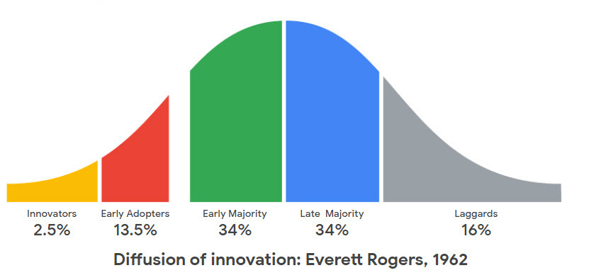
Innovators and Early Adopters will adopt your change independently but these make up only ~15% of the community. The rest will need help.
In his book Crossing the Chasm, 1991, Geoffrey Moore argues that there is a chasm between the Innovators and Early Adopters and the rest of the population which is difficult for the rest to cross.
That is where the Change Manager comes in.
The Change Curve
When we are confronted by change we tend to react in a common way, represented by the Change Curve. People react to change in predictable ways. Projects do too.
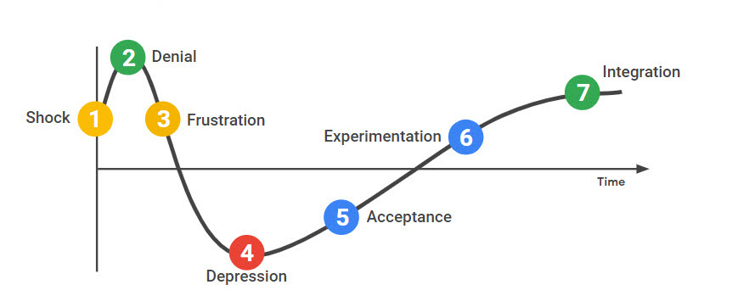
The Change Curve is based on research by Elisabeth Kübler-Ross in the 1960s on the stages of grief. It was recognized that her research was relevant to the workplace and it is commonly applied in organizational change.
- The first reaction to change is Shock. Despite all the evidence to the contrary, we tend to expect things to stay the same.
- Next, we Deny. This cannot be happening. Why do we have to change? What was wrong with how we did things before?
- Then we become Angry and Frustrated. It is common to look for someone or something to blame: ‘nobody told me about this’, ‘they’re always changing things around here’.
- When it becomes obvious that the change cannot be resisted, morale is at its lowest. Performance drops and people fixate on small things that annoy them.
- Eventually we Accept that the change is inevitable and we begin to Experiment with the new situation.
- Finally the change is Integrated into our working lives and performance improves.
A well-managed Change process flattens the peaks of Denial and Depression, and shortens the timeline to Integration.

The Value of Change Management
Introduction
Many companies still see Change Management as an optional part of a deployment. This is not so, and the research bears it out. Large scale transformation only happens with wide ranging changes and processes.
In the Raconteur Report, leaders were asked to rate their companies’ attitude to change and they were also asked to rate how effective they felt their most recent Change Management program had been, as either:
- Excellent and sophisticated
- Adequate but simple
- Poor or none
The results are summarized below.
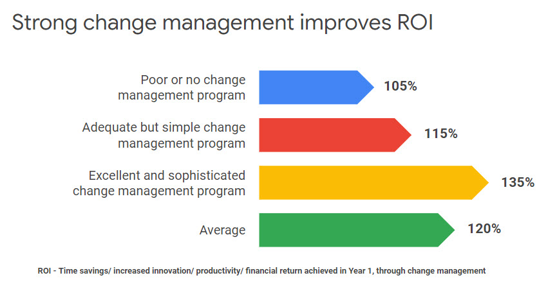
The data shows that on average companies that innovate using a Change Management process report a 120% return on investment. This rises to 135% where leaders rate their change management program as excellent and sophisticated. In particular companies with a long culture of adopting change management do better.
This report was commissioned by Google. There are many other reference sources on the value of change management.
According to a 2014 by Prosci, projects with excellent change management in place are six times more likely to achieve their goals. (Best Practices in Change Management, Prosci, 2014, cited in the Raconteur report.)

Why Projects Fail
Introduction
What about when things go wrong? Here, we explore some of the reasons why projects can fail. If you can avoid making these mistakes, you are on the road to a successful project.
Failure reason #1: Incorrectly thinking that it’s all about the technology!
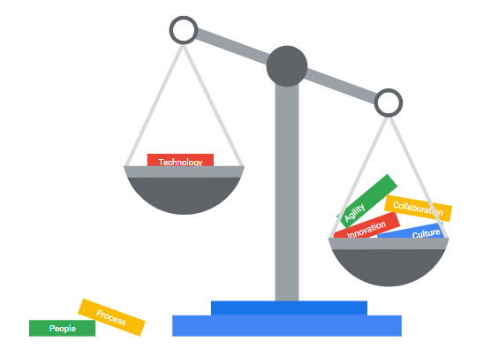
It is critical to get the technology right, but technical staff often allow it to blind them to the other factors that can make-or-break the solution's implementation. If, for example, the data does not migrate correctly or completely, if the layers of security are making things more complicated rather than less so, or if the move to Google Sheets leaves important macros behind then this is a project that is going to fail.
On the client side, if the project lead has built their career on highly technical projects then it is not surprising if they see a Google Workspace deployment as a technology project. In fact they may not have a work transformation objective at all, and be limited in their project scope to one of successfully rolling out the tools.
If the project is going to change the way people work by making them more collaborative then you will absolutely have to address the behavioral, culture and structural aspects. The more successful projects dedicate more than 60% of project time on these People and Process streams. You cannot make work transformation happen with just a technology replacement.
Failure reason #2: Lack of senior executive support
Senior leadership buy-in is the key indicator of successful work transformation.
Transformation rarely succeeds without the support and drive from the senior team. If you want to embed change you need their support.
Respondents told Raconteur that while people are key to the whole transformation process, executives and senior leaders have the biggest impact throughout a change management process. They perform a number of valuable roles:
- Acquire people
- Source budget
- Create executive alignment: Execs have their own agendas and it is the role of your sponsors to gain everyone’s support
- Create common messaging. When the senior team speaks with one voice it creates a strong sense of direction for everyone
- Remove blockers. Every project will come up against challenges. A strong project sponsor will clear these
- Act as the face of change: Leading by example, through using the tools and behaving collaboratively, will be a powerful incentive for everyone else to do the same
Failure reason #3: Lack of local champions - Google Guides
In the Raconteur research it was shown that giving between 5 and 10% the role of champions who move to Google as Early Adopters and provide peer-to-peer support during deployment and beyond is an important technique for embedding change.
Google Guides can reassure people on the ground that the change is not as daunting as it might seem and that it is going to stick.
Failure reason #4: Assumption that everything will work out
Just as there are a group of people who as Early Adopters can support the change, there will be others who resist the change.
We saw earlier that people are resistant to change. This is natural, they are invested in the way they have done things before and not yet committed to the change that is coming. We also learned that there is a spectrum in how people react to change.
Expecting resistance and managing it is part of the change management process.
Failure reason #5: Thinking that the transformation roadmap follows the migration roadmap!
It is a mistake to think that the path that users will take to change their habits and ways of working will be the same as the migration path.
Migration can be done overnight; Transformation takes time.
Building a migration roadmap is about managing constraints whereas building a transformation roadmap is about managing opportunities.

The Change Manager
Introduction
Now we know what Change Management is, why it is important, and where projects go wrong, let's look at what the Change Manager actually does.
It’s important to understand that Change Manager is a role not a job title. You may not have people in your organization with the job title 'Change Manager' but you most definitely have people with that role.
You may also find that although there is no one with the job title of 'Change Manager' that there is a change team in the project, made up of people with different roles.
People workstream
The People workstream is about all the activities that are necessary to bring everyone on the journey with you. These are activities such as engaging stakeholders, conducting ongoing training and communications, and promoting successes in the organization.
The Change Manager is involved throughout the entire project cycle and beyond. From the pre-sales phase where:
- Stakeholders are engaged
- The project is scoped
- The support model is defined
- Communication and training models are defined:
- Communication involves making sure employees understand the motivation for adopting Google Workspace and how it will affect their day-to-day jobs. Also included are internal marketing and project communications to keep employees enthusiastic about and invested in the transformation.
- Training is crucial to ensuring that knowledge, skills, and behaviours are documented. Training may be delivered in the form of documentation, classroom training, video conference, or other methods.
In the deployment phase, the Change Manager continues to play an important role as they:
- Execute on the support model, training and communication plans
Post deployment, the Change Manager can look to ongoing work transformation. They can establish a dedicated Google team that provides ongoing support and training. They also look at adoption progress for Google Workspace, promote success stories and support users through self-help.
Your roles align
At the same time as you are planning the technical deployment and analyzing technical infrastructure the Change Manager is analyzing the organization and engaging sponsors to promote the project internally.
They will also be planning communications and training for the roll out.
The Change Manager is also looking for business processes that can be improved as a result of the change to more collaborative working.
During the actual deployment, while you are at your most busy going through the three phases of Core IT, Early Adopters, and full Go Live, the Change Manager is deeply focused on business impacts, looking for business processes that can be improved, and concentrating on sponsors, Google Guides, and planning around Go Live activities.
This is your busiest time yet it is important to provide support to the Change Managers during the three phase roll outs.
Process workstream
The Process stream is about providing a structure for the organization to engage with innovation and change.
For a successful transformation of how work gets done the Change Manager looks for business processes that can be improved with increased collaboration and Google Workspace and then redesigns those processes with the appropriate training and communications.
Process stream activities tend to lead the technology implementation. There is no point starting to consider process change once the technology has been embedded and people have begun to solidify their work processes once more.
In our three phase roll out model, the Early Adopters phase is the best moment to involve Google Guides in identifying processes that might benefit from the new collaborative approach.
Transformation Lab
The Transformation Lab is the core tool for helping organizations re-evaluate the way they work. These labs involve brainstorming existing business processes, prioritizing to find the ones that can be most improved, and building prototype solutions using Google Workspace. The magic here is that the business users will see first hand the benefit of collaboration by building the solution in teams during the lab.
As the technical project lead and Google Workspace Administrator, you too can add real value here:
- You have formed strong working relationships with people and teams and may have spotted opportunities for business process transformations.
- The labs process is a great opportunity to share this knowledge and insights with the change team.
- Think long-term: the project is not over once Google Workspace is live. Help your users transition to long-term business process transformation
- Identify and share process opportunities as/if they arise
- Support transformation labs by helping to build more complex prototypes
- Provide technical expertise to help build out Google Workspace solutions
- Seek out or support other long-term technical service opportunities for your organization
The labs are also important across the entire project lifecycle:
- The earlier stages are a critical time for documenting ways in which users are currently using email, calendar and productivity tools, process issues or needs, high impacted users
- Now is also the time to begin preparing logistics
- During the deployment: Hold a lab with Google Guides, continue gathering use cases and prototypes, and socialize the prototypes or identified solutions
- Post deployment: Continue to hold labs, gather use cases and really drive home success stories. Celebrate those who are making a difference with the tools
Another way of thinking about it is as a pyramid.
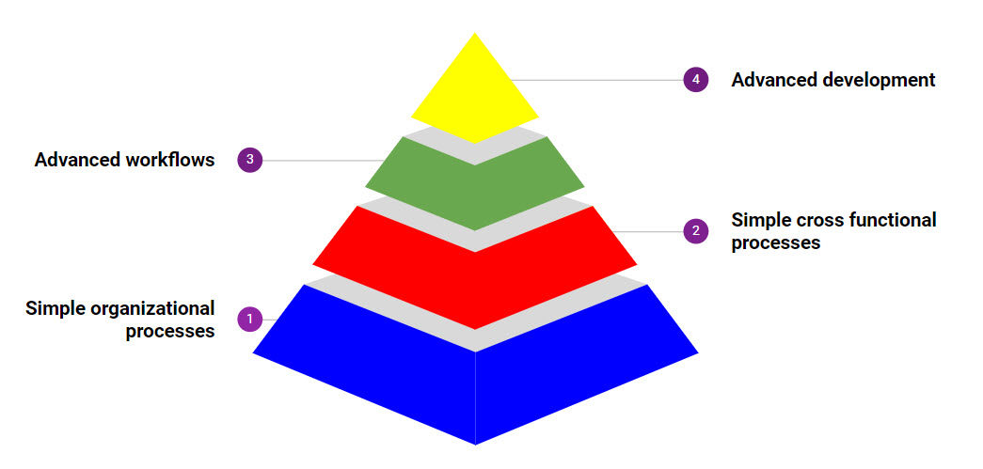
At its base are simple organization processes that can be changed with minimal effort. Typically this will happen within teams, where everyone is brought into the change, and the Change Manager does not have to win the support of other stakeholders.
Once the deployment team is skilled at the process it can look upwards at cross functional processes which may involve other teams, departments and locations. This adds a degree of complexity, in terms of the number of stakeholders and implications and risks in implementing any change. Typically you will be looking for easier to implement high business value changes here.
Only once this process has become second nature to the business should the team attempt high value high risk projects such as advanced workflows or new business models.
Congratulations on successfully completing the Planning for your Google Workspace Deployment course. Let's summarize what you have learned.
What have you learned
As you embark upon your transition to Google Workspace, you should now understand the basic concepts that underpin Google's three phased deployment methodology. You should be able to apply the recommendations and best practices learned here to your own particular organizational needs.
In the Provisioning lesson, you looked at:
- Using DNS records to verify domain ownership
- Different types of domains supported by Google Workspace
- Synchronizing your local directory and provisioning objects in Google Workspace using GCDS
- Developing a strategy for provisioning company resources at each phase of deployment
You then went onto look at Mail Routing where you learned about:
- The different types of mail delivery methods used during each phase of Google Workspace deployment.
- How to configure mail settings in Google Workspace and your legacy platform for mail delivery.
In Data Migration, we discussed:
- The differences between server-side or client-side migrations
- The use of GWMME tool as a solution for Galaxy Sola
- How much data to migrate and how to develop a migration strategy during deployment
and in the Coexistence lesson, you learned about:
- Coexistence types
- The challenges facing users during a deployment and in particular around calendar coexistence
Finally you were introduced to the importance of Change Management for your deployment. You discovered that:
- People have a natural resistance to change. Less than 20% of people in a typical organization will adapt to change easily
- You must not think about a Google Workspace deployment solely as a technical project. You must also consider the people and the processes to ensure its success
- Change management is not an optional part of the project. It is integral to the success of the project

