how to migrate an enterprise workload into the cloud
https://cloud.google.com/architecture/migration-to-gcp-getting-started
start by defining the environments that are involved in the migration. Your starting point can be an on-premises environment, a private hosting environment, or another public cloud environment.
define the workload types and the related operational processes that are in scope for the migration. This document considers two types of workloads and operations: legacy and cloud-native.
workload types, your starting situation is one of the following:
- On-premises or private hosting environment with legacy workloads and operations.
- On-premises or private hosting environment with cloud-native workloads and operations.
- Public cloud or private hosting environment with legacy workloads and operations.
- Public cloud or private hosting environment with cloud-native workloads and operations.

Types of migrations
There are three major types of migrations:
- Lift and shift
- Improve and move
- Rip and replace

Google Cloud Adoption Framework
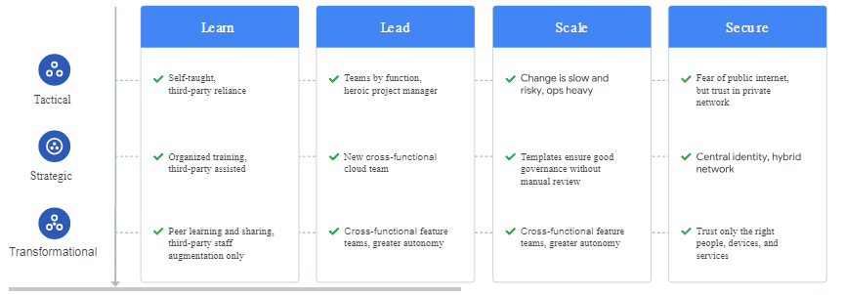
framework assesses four themes:
- Learn. The quality and scale of your learning programs.
- Lead. The extent to which your IT departments are supported by a mandate from leadership to migrate to Google Cloud.
- Scale. The extent to which you use cloud-native services, and how much operational automation you currently have in place.
- Secure. The capability to protect your current environment from unauthorized and inappropriate access.
For each theme, you should be in one of the following three phases, according to the framework:
- Tactical. There are no coherent plans covering all the individual workloads you have in place. You're mostly interested in a quick return on investments and little disruption to your IT organization.
- Strategic. There is a plan in place to develop individual workloads with an eye to future scaling needs. You're interested in the mid-term goal to streamline operations to be more efficient than they are today.
- Transformational. Cloud operations work smoothly, and you use data that you gather from those operations to improve your IT business. You're interested in the long-term goal of making the IT department one of the engines of innovation in your organization.

The migration path
It's important to remember that a migration is a journey. You are at point A with your existing infrastructure and environments, and you want to reach point B. To get from A to B, you can choose any of the options previously described.
The following diagram illustrates the path of this journey.
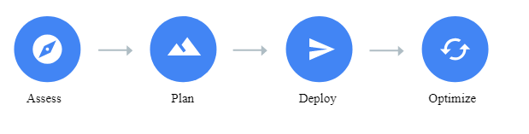
There are four phases of your migration:
- Assess. In this phase, you perform a thorough assessment and discovery of your existing environment in order to understand your app and environment inventory, identify app dependencies and requirements, perform total cost of ownership calculations, and establish app performance benchmarks.

Take inventory, Catalog apps,Educate your organization about Google Cloud, Experiment and design proofs of concept, Calculate total cost of ownership, Choose which workloads to migrate first

- Plan. In this phase, you create the basic cloud infrastructure for your workloads to live in and plan how you will move apps. This planning includes identity management, organization and project structure, networking, sorting your apps, and developing a prioritized migration strategy.
- Establish user and service identities.
- Design your resource organization.
- Define groups and roles for resource access. An organization admin, A network admin, A security admin, A billing admin
- Design your network topology and establish connectivity. VPC, network flows, Firewall Rules Logging

Deploy. In this phase, you design, implement and execute a deployment process to move workloads to Google Cloud. You might also have to refine your cloud infrastructure to deal with new needs. Fully manual deployments, Configuration management tools, Container orchestration, Deployment automation, Infrastructure as code(Terraform)
- Optimize. In this phase, you begin to take full advantage of cloud-native technologies and capabilities to expand your business's potential to things such as performance, scalability, disaster recovery, costs, training, as well as opening the doors to machine learning and artificial intelligence integrations for your app.

Disaster recovery and availability from a cloud standpoint
https://cloud.google.com/architecture/dr-scenarios-planning-guide
DR is a subset of business continuity planning. DR planning begins with a business impact analysis that defines two key metrics:
- A recovery time objective (RTO), which is the maximum acceptable length of time that your application can be offline. This value is usually defined as part of a larger service level agreement (SLA).
- A recovery point objective (RPO), which is the maximum acceptable length of time during which data might be lost from your application due to a major incident. This metric varies based on the ways that the data is used. For example, user data that's frequently modified could have an RPO of just a few minutes. In contrast, less critical, infrequently modified data could have an RPO of several hours. (This metric describes only the length of time; it doesn't address the amount or quality of the data that's lost.)

DR planning, including the following:
- A global network. Google has one of the largest and most advanced computer networks in the world. The Google backbone network uses advanced software-defined networking and edge-caching services to deliver fast, consistent, and scalable performance.
- Redundancy. Multiple points of presence (PoPs) across the globe mean strong redundancy. Your data is mirrored automatically across storage devices in multiple locations.
- Scalability. Google Cloud is designed to scale like other Google products (for example, search and Gmail), even when you experience a huge traffic spike. Managed services such as App Engine, Compute Engine autoscalers, and Datastore give you automatic scaling that enables your application to grow and shrink as needed.
- Security. The Google security model is built on over 15 years of experience with helping to keep customers safe on Google applications like Gmail and Google Workspace. In addition, the site reliability engineering teams at Google help ensure high availability and prevent abuse of platform resources.
- Compliance. Google undergoes regular independent third-party audits to verify that Google Cloud is in alignment with security, privacy, and compliance regulations and best practices. Google Cloud complies with certifications such as ISO 27001, SOC 2/3, and PCI DSS 3.0.
DR patterns are considered to be cold, warm, or hot

Compute and storage

What are the advantages of serverless computing?

No server management is necessary,

Developers are only charged for the server space they use, reducing cost

Serverless architectures are inherently scalable,

Quick deployments and updates are possible,

Code can run closer to the end user, decreasing latency,

What are the disadvantages of serverless computing?

Testing and debugging become more challenging

Serverless computing introduces new security concerns,

Performance may be affected,

Vendor lock-in is a risk,

Who should use a serverless architecture?

decrease their go-to-market time and build lightweight, flexible applications that can be expanded or updated quickly may benefit greatly from serverless computing.

reduce costs for applications that see inconsistent usage, with peak periods alternating with times of little to no traffic

push some or all of their application functions close to end users for reduced latency will require at least a partially serverless architecture

Considerations for relational vs. NoSQL systems
CONSIDERATIONS FOR RELATIONAL VS. NOSQL SYSTEMS
Consider a NoSQL datastore when: | Consider a relational database when:
You have high volume workloads that require large scale | Your workload volume is consistent and requires medium to large scale
Your workloads don't require ACID guarantees | ACID guarantees are required
Your data is dynamic and frequently changes | Your data is predictable and highly structured
Data can be expressed without relationships | Data is best expressed relationally
You need fast writes and write safety isn't critical | Write safety is a requirement
Data retrieval is simple and tends to be flat | You work with complex queries and reports
Your data requires a wide geographic distribution | Your users are more centralized
Your application will be deployed to commodity hardware, such as with public clouds | Your application will be deployed to large, high-end hardware
Based upon specific data requirements, a cloud-native-based microservice can implement a relational, NoSQL datastore or both.

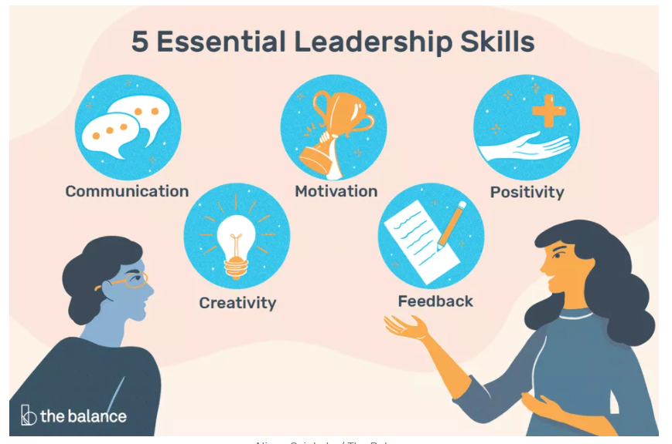

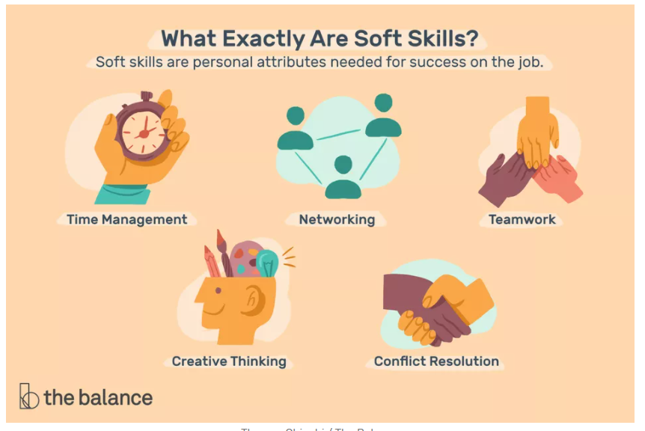

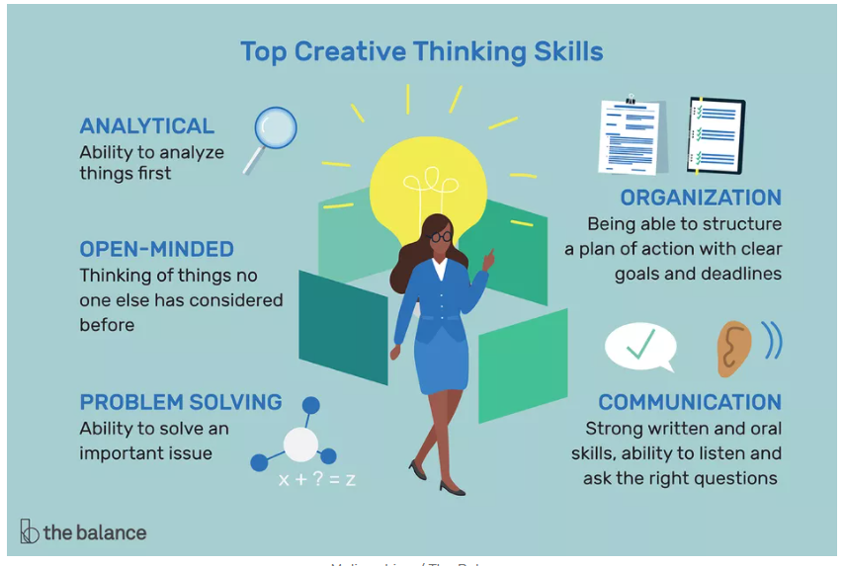

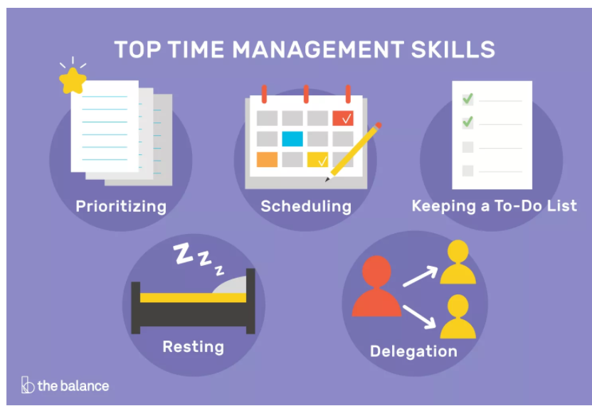

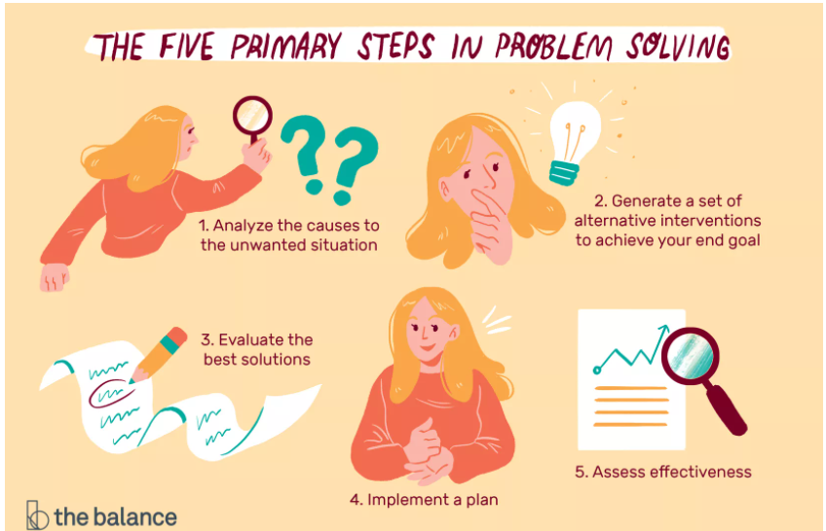

https://www.thebalancecareers.com/problem-solving-skills-with-examples-2063764
- Problem-solving starts with identifying the issue, coming up with solutions, implementing those solutions, and evaluating their effectiveness.

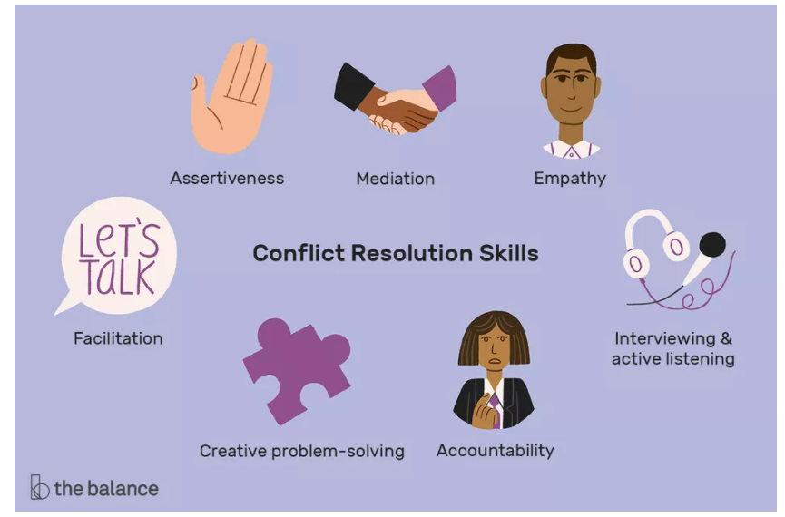

https://www.thebalancecareers.com/what-is-a-sales-manager-2917362

https://cloud.google.com/architecture/migration-to-google-cloud-building-your-foundation

Google Cloud vs AWS in 2021 (Comparing the Giants)

business-critical categories

Service support, platform stability, pricing, and billing structure.

compute capabilities- focusing on virtual machines

