Objective  Lives data and believe in people.  Sets high goals and leads the system to them.  Skills  Independence - An independent thinker and pushes processes independently.  Planning – Set goals, break them to objectives and plan the road to them.  Drive for improvement – Always seek for the most efficient way to work.  Hobbies  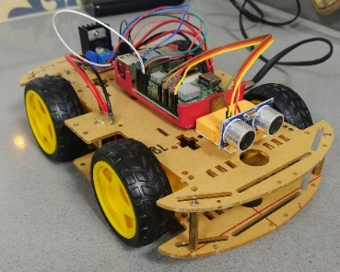 | Experience  BIG Data Engineer • Mobileye • Since 2017  Processing and analyzing big data clusters, establishing robust ETL pipelines with Python.  Designee and implement the main Mobileye metadata DB product, based on NoSQL database MongoDB.  Implement smart ML models with Sklearn and Pandas for data classification.  Designed a robust, cloud based, data lake solution.  Project analyst • Intel Corporation • 2016-2017  Developing BI systems for bugs including trend analysis and reports  officer • IDf • 2012 - 2014  Serve as a platoon commander in the Paratroopers Brigade, a graduate officers warrior.  Education  Engineer’s Degree, Industrial Engineering • 2018 • JCT  Specializing in information systems, GPA – 87.  Final project in Machine learning- GitHub  Master's Degree, Data mining • 2021 • JCT  Specializing in Deep Neural Networks, GPA – 92  Expertise in languages and softwares  SW – Python (Including: pandas, sklearn), Shell, C#  ENV – Linux, AWS , Docker, Docker compose  Query - SQL , MongoDB QL,  ECOSYSTEMS – Jenkins (CI,CD) , JIRA, GIT
  Ben Zacharia, Mordechai
  DATA-DRIVEN developer

