 |  |  | RAM  KADOSH  WORK EXPERIENCE  computer repair technician  2020 /03/01–2021/03/01  I worked as a freelancer.  Projects  Media Player  2019 /06/10–2019/07/01  using javaFX with Sliders and javaFX menus  Messenger  2019 /07/05–2019/08/15  Create GUI using java , use on Client and Server.  Zigzag  2019 /08/25–2019/09/31  a Game using on C# in Unity.  EDUCATION  The Open University  2019-2023  a student in The Open University for B.Sc. in Computer Science Second year.  COURSES  - Pc technician-01/20-03/20  - RHCSA -Linux Admaonstrator 03/19-05/19  - CCNA - 05/19-08/19  - Penetration Testing 08/19-10/19  - Malware 10/19-12/19    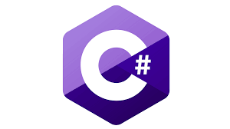      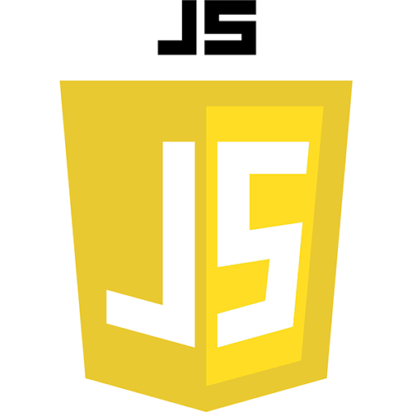        SKILLS

Profile
I am always looking for new ways to improve myself and my knowledge,
In any way .
Currently,
I am Study a new courses,
in parallel,
with my degree.

LANGUAGE
Hebrew


English

CONTACT
PHONE:
0545425774

EMAIL:
Ramkadosh7726@gmail.com



