Ziv Staeinberg
Address : Kfar Yona
Mobile : +972 – 54 – 2493152
Email : zivshtaeinberg@gmail.com
OBJECTIVE

CTO, where excellent technical skills and professional experiences will add a value to the company operation.
CURRENT EMPLOYMENT

AspireGlobal LTD(2018 – Today): http://www.aspireglobal.com/
Chief Technology Officer and Site Manager
Products: iGaming Platform (Games, Payment, Finance, Identity - KYC, RISK, Integration and more)
Customers: B2B and B2C
Platform: Hybrid solution - On Premise and Cloud: Azure and AWS, PaaS & SaaS.
Leading AspireGlobal Architecture, Software, QA, IT Engineering, Production, Service Management, Operations and Information. Management Analytics organization.
Focusing on Company Digitalization Journey with advanced Microservices architecture for high TRX
Performance & Stability.
leadership and management experience in a production, mission-critical, 24x7 operations environment.
High experience in managing large vendors multi-year contracts and operating entities.
Experience leading, directly managing, and influencing a diverse organization of full-time employees, across multiple disciplines and platforms.
Video

PROFESSIONAL EXPERIENCE

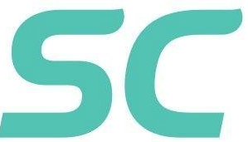Safe Charge (2017 – 2018): https://www.safecharge.com/
Global Chief Technology Officer
Products: Payment Solution Platform & Acquiring Solutions (Payment, Finance, Identity, RISK and more)
Customer Suit Systems, Azure and AWS, PaaS & SaaS.
Team Size: 130 Engineers (SW, QA, Security Engineers and more).

Lead SafeCharge Architecture, Software, QA, IT Engineering, Service Management, Operations and Information. Management Analytics organization, Staff of 150 employees and contractors in 2 countries with a budget of $15M+.
- Modernized Datacenter including Cloud Platforms, Global endpoints, high scale and availability.
- Drove organization towards Platform&Information-as-a-Service, leveraging Big Data and Advanced Visualization.
- System SLA – High performance and Scale.
- Create IT Service Management and Capabilities
- Transformed software deliveries be implementing enterprise service bus and business rule engine.
- Leading & Guiding Managers for best performance to achieve challenging goals.
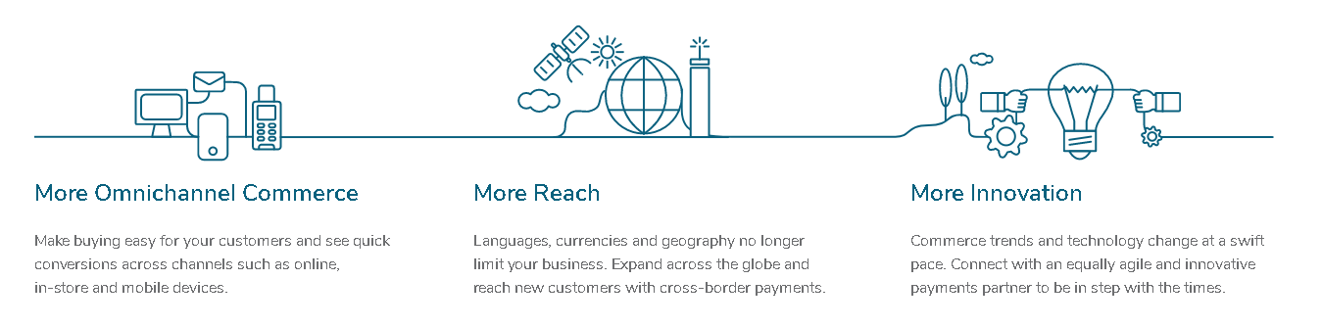
Microsoft (2014 – 2017).
ISL Cloud Solution Architect
Products: Microsoft Azure Platform Products.
Customers: Teva, Amdocs, Bank Hapoalim, Bank Haleumi, Governments & IDF.
Team Size: Cloud Architects, SW Engineers & QA Engineers.

SuperCom, Israel (2014 – 2016).
R&D Director and Country Manager.
Products: Government Projects.
Team Size: 26 SW Engineers & 5 QA Engineers.
SuperCom ∑ID™ (Sigma-ID) Division is a System House and a System Integrator active in the National ID. Working exclusively with Governments and Public Sectors, SuperCom ∑ID™ is an internationally recognized leader in the design, development, integration and delivery of highly secured National ID.

Marvell & UIU LTD , Israel (2011 – 2013).
VP R&D and VC Technical Adviser.
Product: Android Mobile Suit Systems, Cloud Architect Management & SaaS.
Team Size: 26 SW Engineers & 2 QA Engineers.

Marvell LTD, Israel (2007 – 2012).
Senior Software Manager (Group Manager)
Product: PC & Mobile Applications for Silicon Development, Integrations, Debugging, SV & Production Line. (Video Telephony, RF Calibration, Mobile Phone – Remote Server, Protocol Analyze & much more…)
Team Size: 32 SW Engineers and 4 QA Engineers
(Including Remote Management Ukraine & Taipei).

Tadiran Telecom, Software Engineer (2002 - 2007) Tanzania & Petach Tikva
R&D Director
Projects: Computerizing Government Legal System & Telecommunication for Billing Machine.
Client : Tanzania Government & World Bank.
Team Size : 24.
Our product was used for generating legal electronic bills and to store the bill information. The billing information can be retrieved, viewed and reprinted. The stored billing records can be used for tax commutation. We also provided inventory/stock information.
EDUCATIONAL DETAILS

Course | College/University | Year | Aggregate
BA Computer Science & Management | University of Tel Aviv. | 2002 | 88
MCSE | College of Ramat Gan | 2000 | Microsoft Certificate - 6 MCP
ADDITIONAL CERTIFICATIONS:
KMDF Programming, Certified by Microsoft. SQL, DBA Pro6 Pogramming, Certified by Microsoft”. Android, Certified by “John Brice”. Learn to Lead & Management Expertise “University of Tel Aviv”.Azure Development Certification


